思路：

## Inspiration

First of all, we noted this pro due to the severe pollution of the Xiangjiang River and the Huaihe River. The arsenic content of the main contaminated areas of Xiangjiang Rive exceeded 715 times at maximum, and the cadmium content exceeded 206 times at maximum.

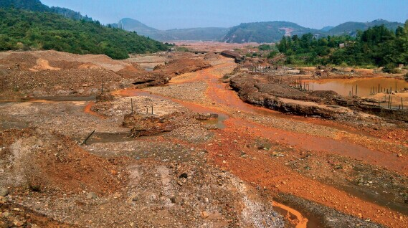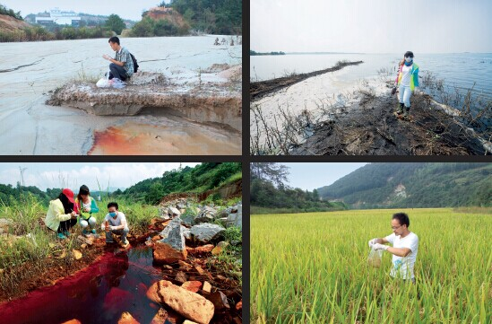

In Chenzhou thirty-six Bay mining area, arsenic content of Ganxi River sediment exceeded 715.73 times. In Ganxi village’s paddy field, cadmium content exceeded 206.67 times. The highest content of lead in paddy field reached to 1527.8mg / kg (that is per kilogram containing 1.5 grams), exceeding 5.093 times.

## Looking for help from environmental protection departments

First of all, we note this pro because of the severe pollution of the Xiangjiang River and the Huaihe river. We began to do some survey to find out whether the heavy metal pollution incident is particularly prominent not only in China but also all over the world. So we began to evaluate the meaning of our project. First, we started from China. We visited the Chinese Ministry of Environmental Protection which is the highest environmental protection departments in China. We asked them how serious the heavy metal pollution is in China now. The Vice Minister of Environmental Protection of China told us that the part of Yangtze River near the coast, which has the water of the best quality in our seven major river systems has been affected by heavy metal pollution including Cd, Cu and Pb. And in the 21 cities along the river, six cities' percentage of heavy metal pollution accumulation has reached 65%. So we focus our treatment on cadmium and copper.

## Set up an alliance

 Then we established the China Heavy Metal Pollution Research and Investigation Alliance, which consists of SJTU / SCUT / XMU / UCAS / JLU / FAFU.

Those are teams that involved in reseachers about water pollution or heavy metal pollution treatment in China. We discussed ideas and achievements of our own teams together, and we hope to build a database by coperating with each other, which contains data of heavy metal pollution from different regions around the world, looking forward to making it shown in the form of maps. At the same time we would like to be able to play our own efforts to hold some science popularization activities, which aims to attach importance to the issue of heavy metal pollution. In order to be able to make a real and effective database containing heavy metal pollution data around the world, we also launched an invitation on the official website of collaboration, called for more iGEM teams to join our alliance or to provide some data and information. As a result, we received mails from iGEM EXETER, iGEM CSMU X NCHU TAIWAN and Nazarbayev, and Exeter provided us with European data and shared their own protocol with us. Besides, CSMU X NCHU TAIWAN provided us with statistical information on heavy metal pollution in Taiwan and listed the major pollution incidents in Taiwan in recent years for us. According to the results provided by the database, by using the alliance’s forces, we speared the questionnaire designed by us about the situation of heavy metal pollution throughout the country, and in the end we received nearly 1,000 replies. Some of the answers we received surprised us a lot.

## Consultation in many ways

In this situation, we consulted Professor Qu Hongyan who works at the School of Environmental Sciences at Tianjin University. He told us that the study of heavy metal removal from groundwater is a very important subject that still needs to be studied. It is of great value to use micro-organisms in heavy metal removal. So we decided to carry out our subject in the field of heavy metal removal.

Then, we learned that recently the heavy metal deposition research center in Hunan has made a great breakthrough. So we held a telephone conference to communicate with their technical teacher. During the conference, we asked the current situation about heavy metal pollution, and consult their approach to chromium ions sedimentation. That is turning high-valent chromium into low-valent chromium to reduce toxicity. This inspired us to think about if there is any better way to completely settle the chrome ions from the water.

## Source of pollution: electroplating factory, electric drill factory

Because our experiment needs to design for the actual problem in our life, at the start, we left school for the electroplating factory in Shanxi Province and electric drill factory in Henan Province.

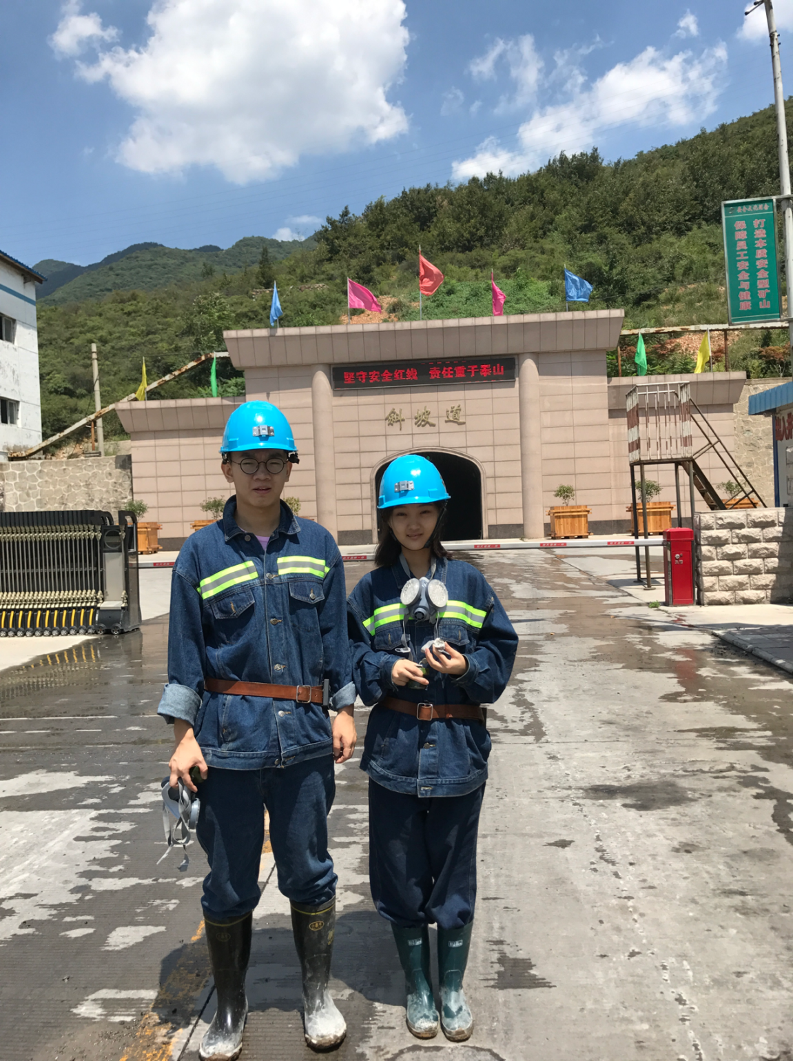

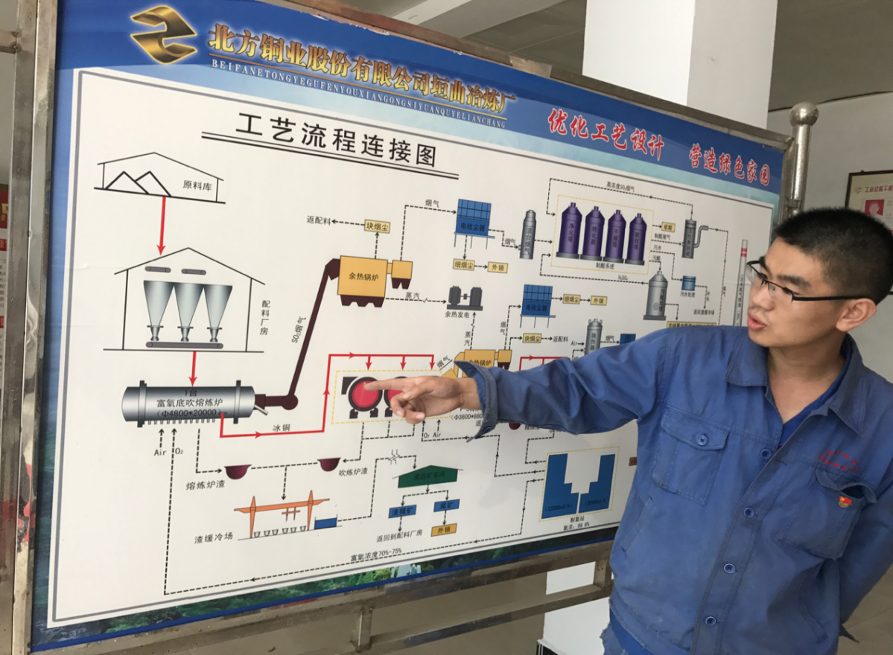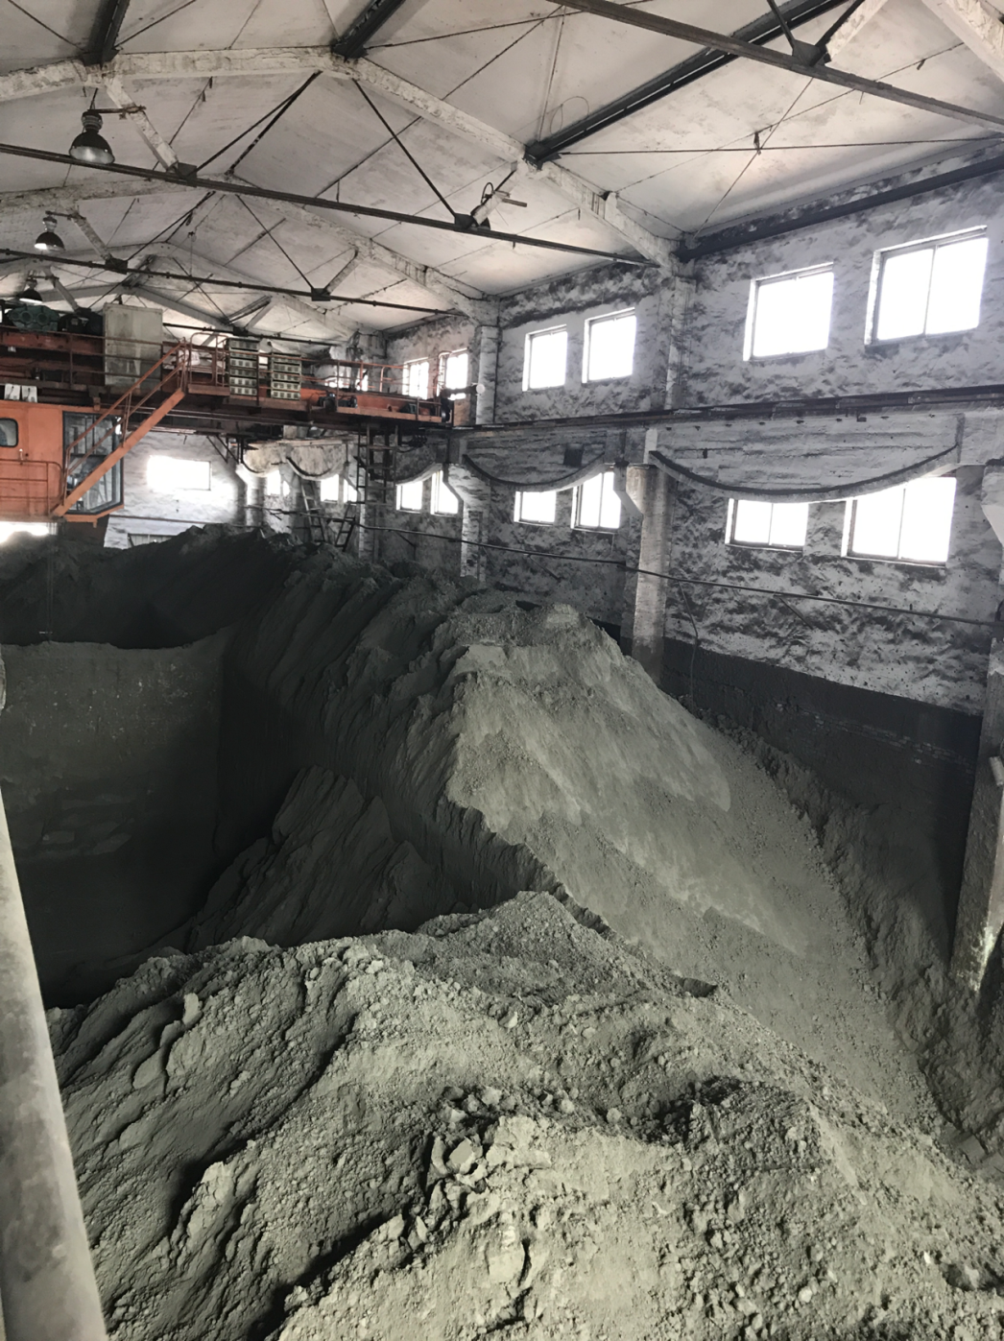

The electroplating factory mainly produces copper and cadmium ion while the electric drill factory mainly produces cadmium and nickel. They proposed that different heavy metals are treated by different methods. 90% of the treatment is chemical methods while 10% is biological methods. But most of time, in order to deal with that two kinds of heavy metals, some factories tend to use simple and quick ways which can be harmful to the environment.

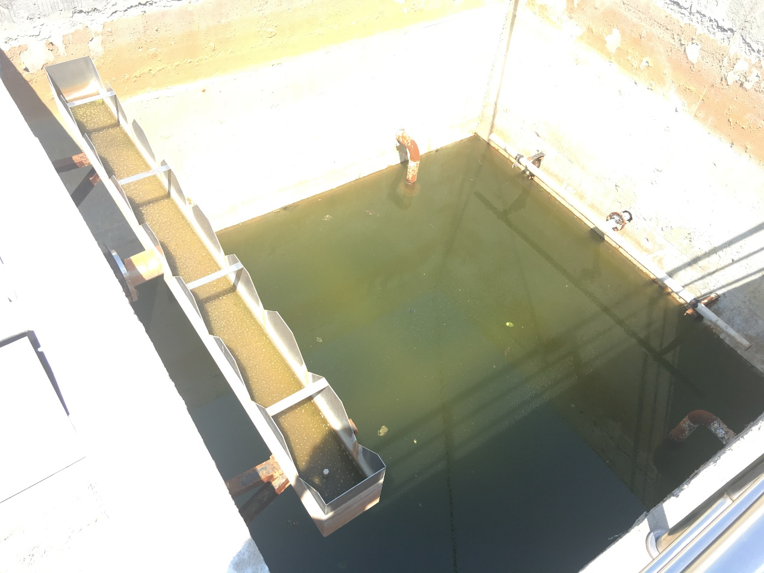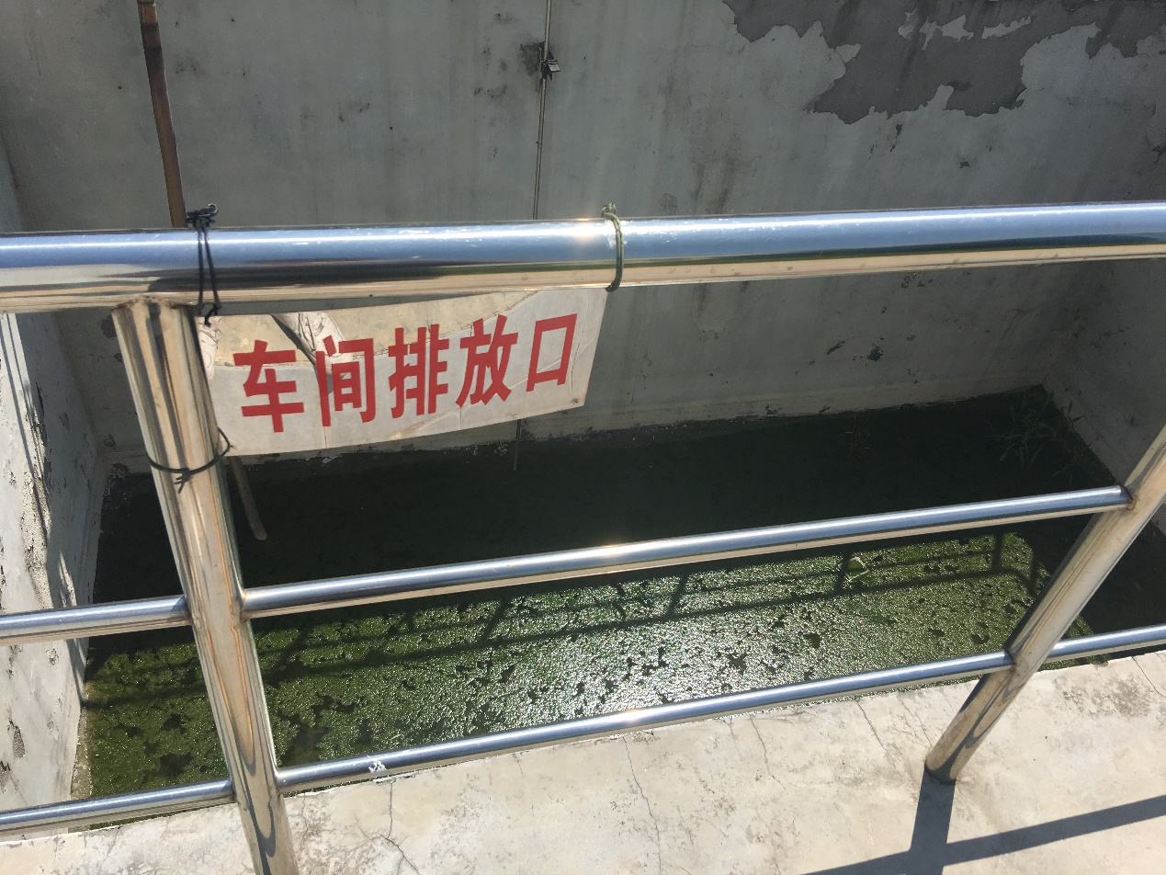

化学处理产生的废液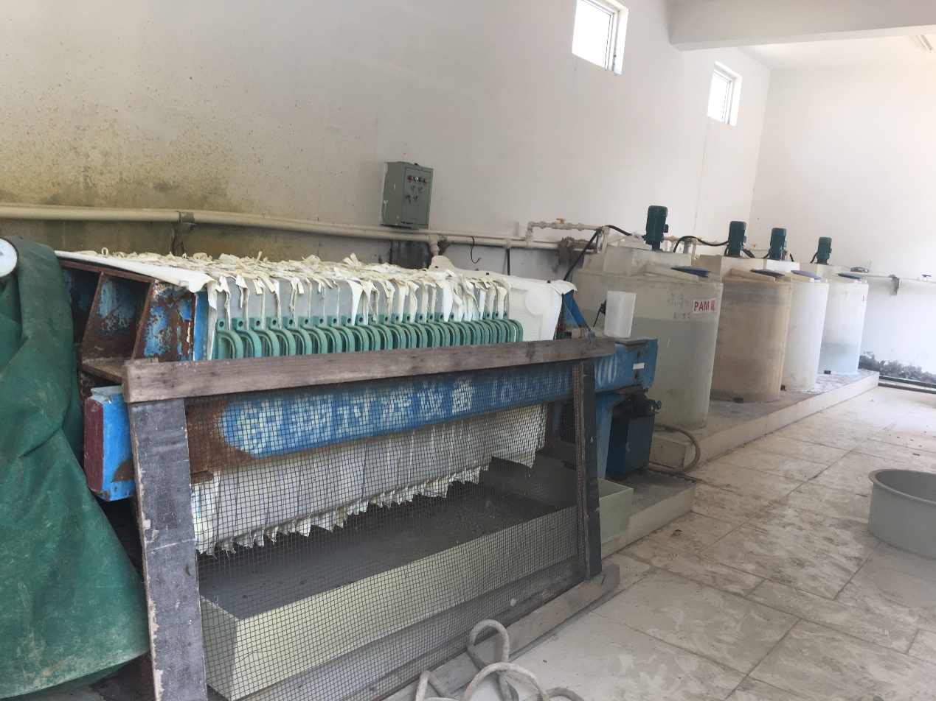 And some of the factories directly choose to only deal with one kind of the heavy metals that has a larger amount, then abandon another kind of heavy metal without treatment. Based on the current situation that the treatment for a variety of heavy metals are not well developed, the issue about how to deal with a variety of heavy metals contained in polluted water has been considered as the primary problem, we hope to use a bacterium to collected two metals separately in different periods.

For the difficulty of settling multiple heavy metals in a step-by-step manner, and based on the naturally occurring mating-type switch in Saccharomyces cerevisiae, we decided to use Saccharomyces cerevisiae as a chassis and proposed the concept of mating switcher. The members of our experimental group came up with the idea of ​​combining the gender conversion with the functional conversion of Saccharomyces cerevisiae to solve the problem of stepwise subsidence of copper ions and cadmium ions.

**Seek advice by communication with other teams**

After those surveys, we had a meeting with Professor Zhang Haoqian and the leader Zhang Yihao from Peking team of Peking University. They expressed a keen interest in our team's mating switcher, and pointed out the defects of our experiment: 1. How can we improve the specificity of yeast to absorb heavy metals? 2. How to separate these two metals?

**Detection problems: domestic sewage treatment plant**

With some problems to solve, we went to the domestic sewage treatment plant of Wugang City, Henan Province. The processing plant is representative, but we found that as a demonstration unit of the sewage treatment plant, they did not detect heavy metal ions usually. Only when the heavy metal content exceeded standard emissions, the information can be transferred to the Environmental Protection Agency. Thus, there exists two problems. 1.Domestic sewage treatment plant does not have its own set of detection system. 2. Once the heavy metal content exceeded, there is no corresponding solution.

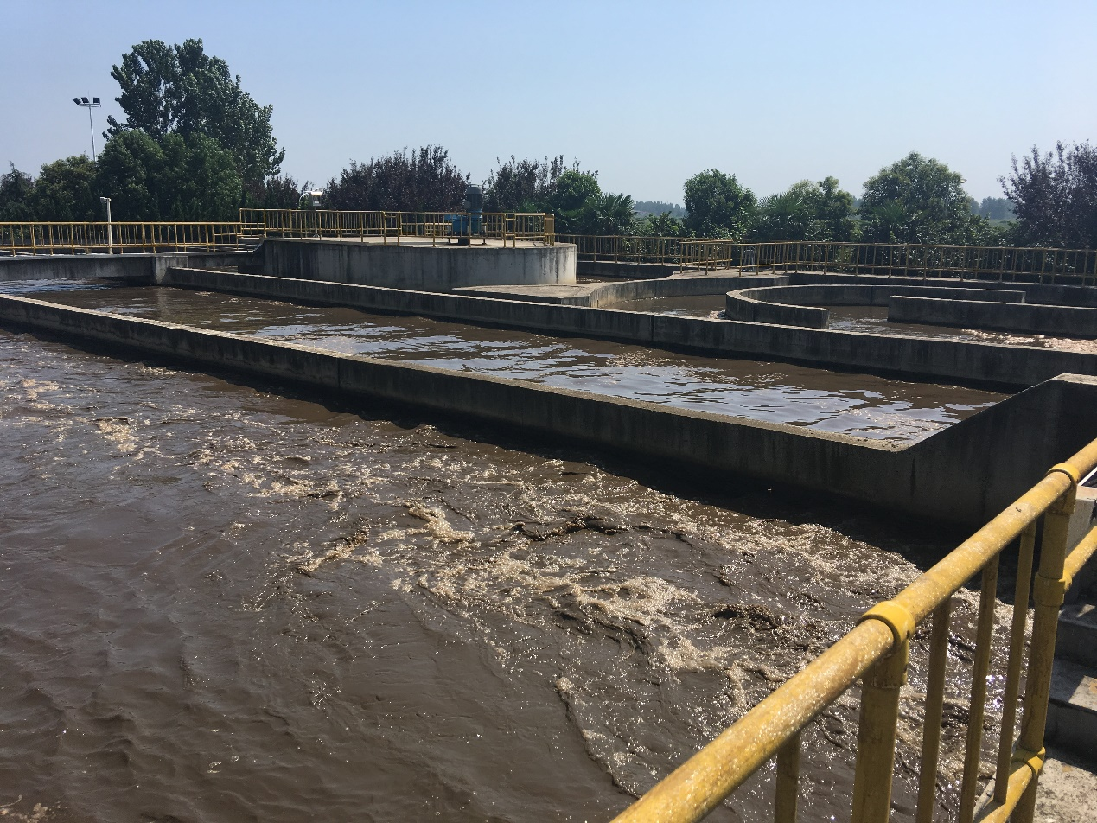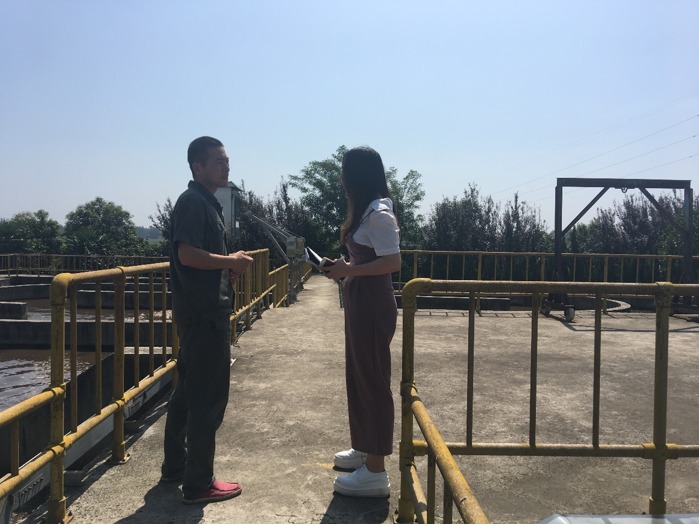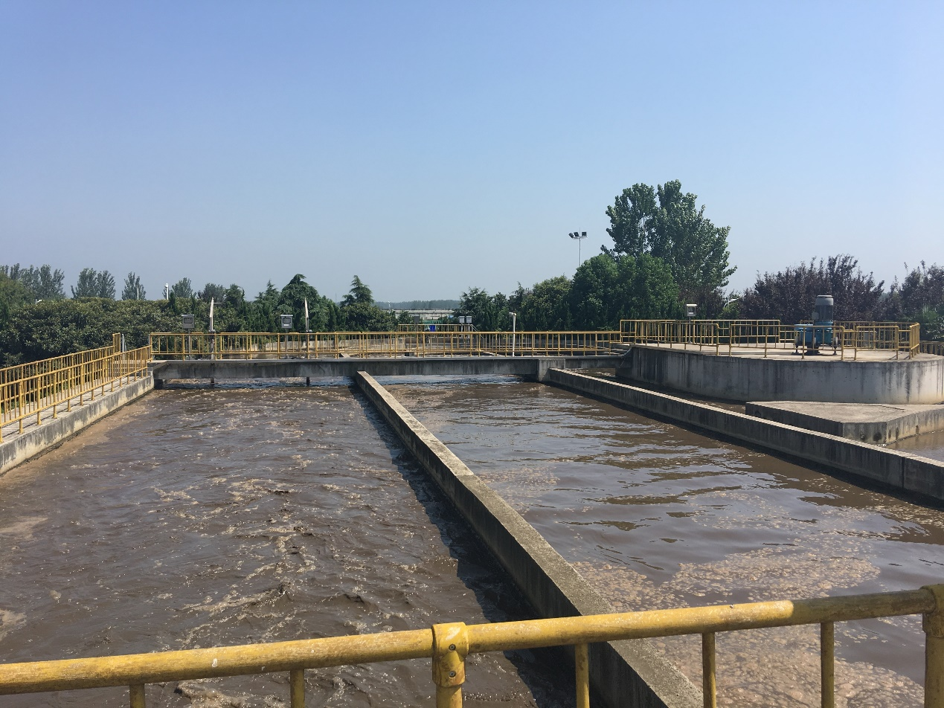

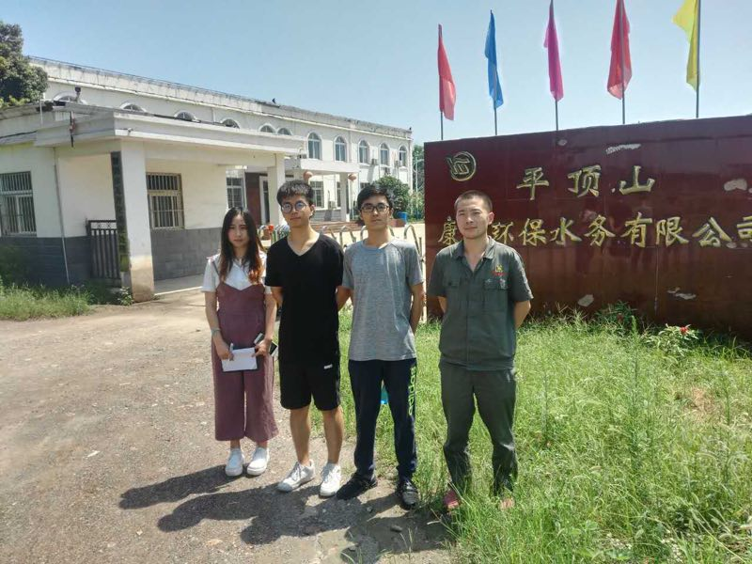

同时我们了解到，处理生活污水的过程中主要用到混菌，所以我们希望能够将我们的酵母投入混菌中共同处理污水，这就需要一个检测器。

16年华盛顿的项目中，他们选择了铜离子诱导的启动子cup1p 并由该启动子开启rfp，通过红色荧光的检测，我们将得知何时铜离子的浓度高低沉降完全，并且开启功能转换开始处理铜离子。我们将cup1检测系统导入到A类酵母中，实现检测与处理的分离，避免重金属的积累对检测造成影响。但是，由于该启动子存在泄露表达的问题，我们将用易错pcr的方法提升启动子的灵敏度并降低表达阈值。 为了达到人为控制mating switcher的目的，我们引入人工转录因子z4ev和改造后的gal 启动子来严格控制HO基因的表达。 在没有雌激素的情况下，z4ev上的热热季蛋白受体会与hsp90结合。在加入雌激素之后，雌激素替换hsp90，使z4ev能够与gal启动子结合开启下游基因的表达。

## 耐受性问题：钢铁公司

我们之后带着自己的想法与河南省河钢集团舞钢公司的污染部的技术人员交流,（河南省河钢集团舞钢公司是中国首家宽厚钢板生产和科研基地,鸟巢、重庆朝天门大桥、上海中心大厦的主承重框架均来自此公司）他们带领我们参观了他们循环处理工业废水的设备，并且告诉我们现在一般是将工业废水排放到一个污水聚集池，再集中处理此内的重金属离子，因为工业污水中重金属离子含量高，所以一般菌种达不到这样的耐受性，并且使用微生物处理需要氧气，营养条件达到，所以希望我们能够提高菌种的耐受性，并且提出，如果我们的菌种能够达到要求，他们愿意为我们做第一批试验批。

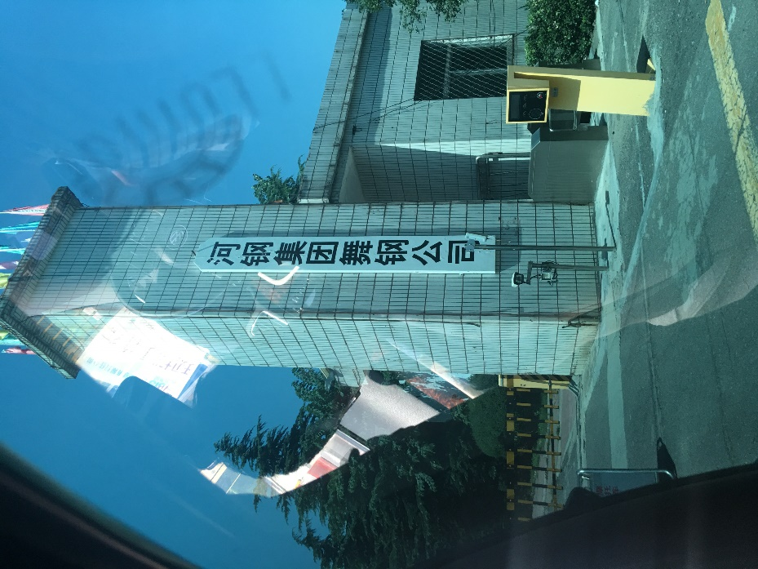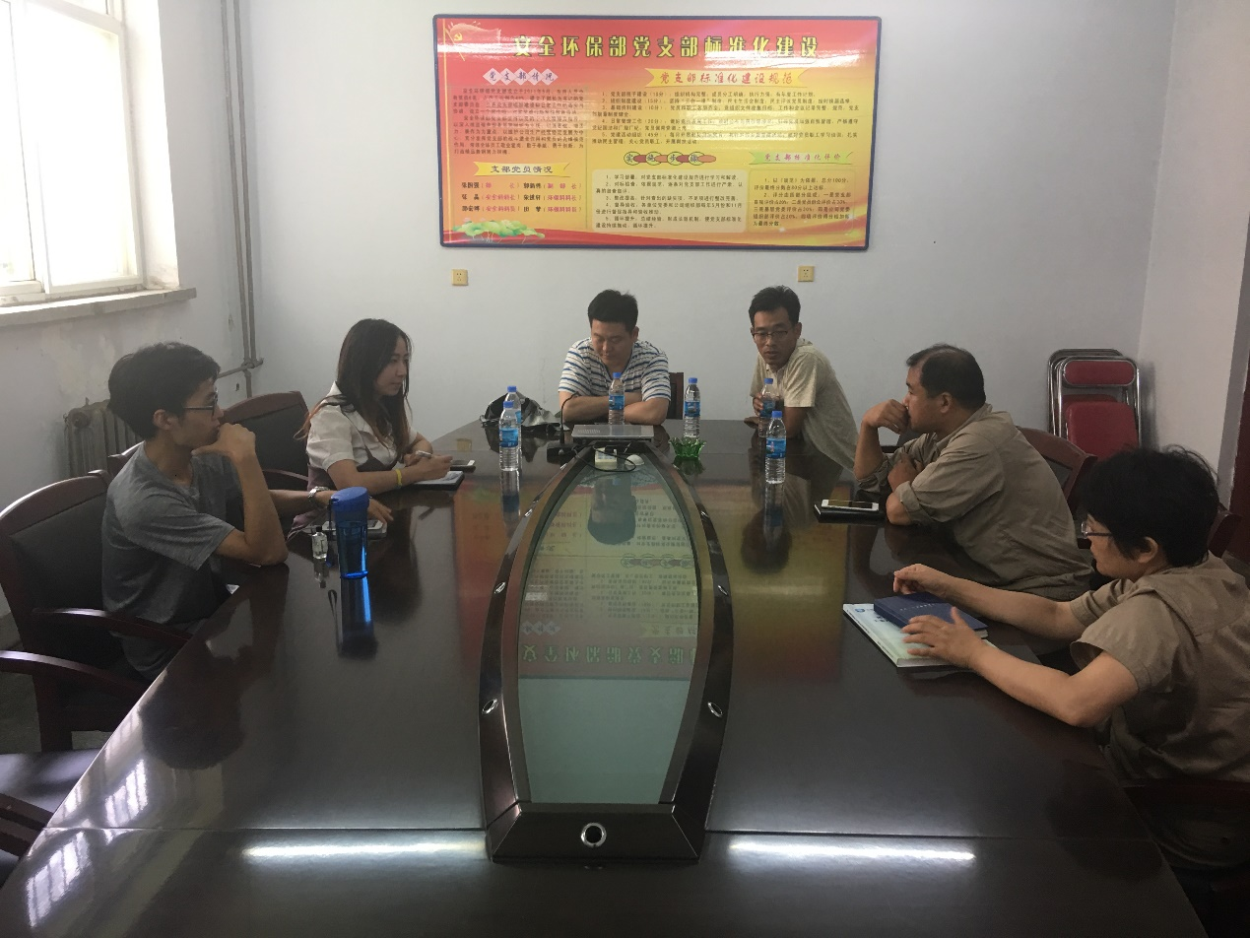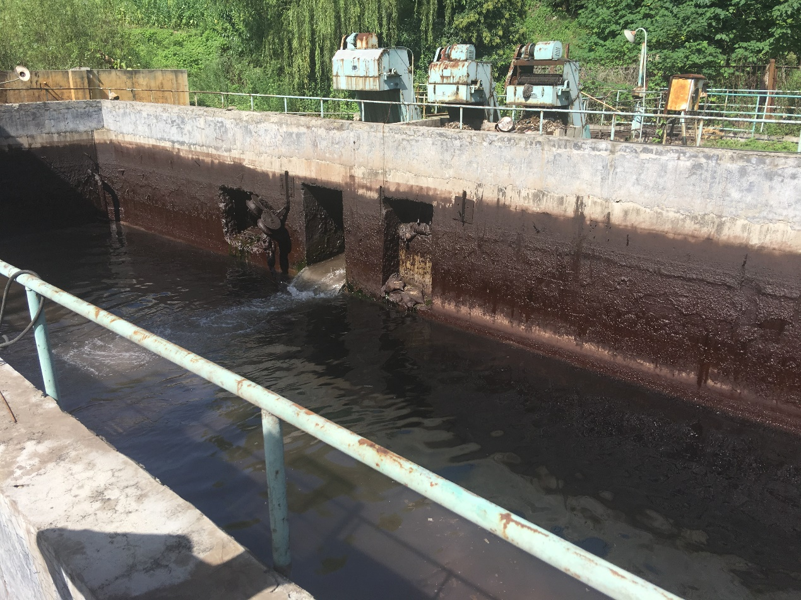

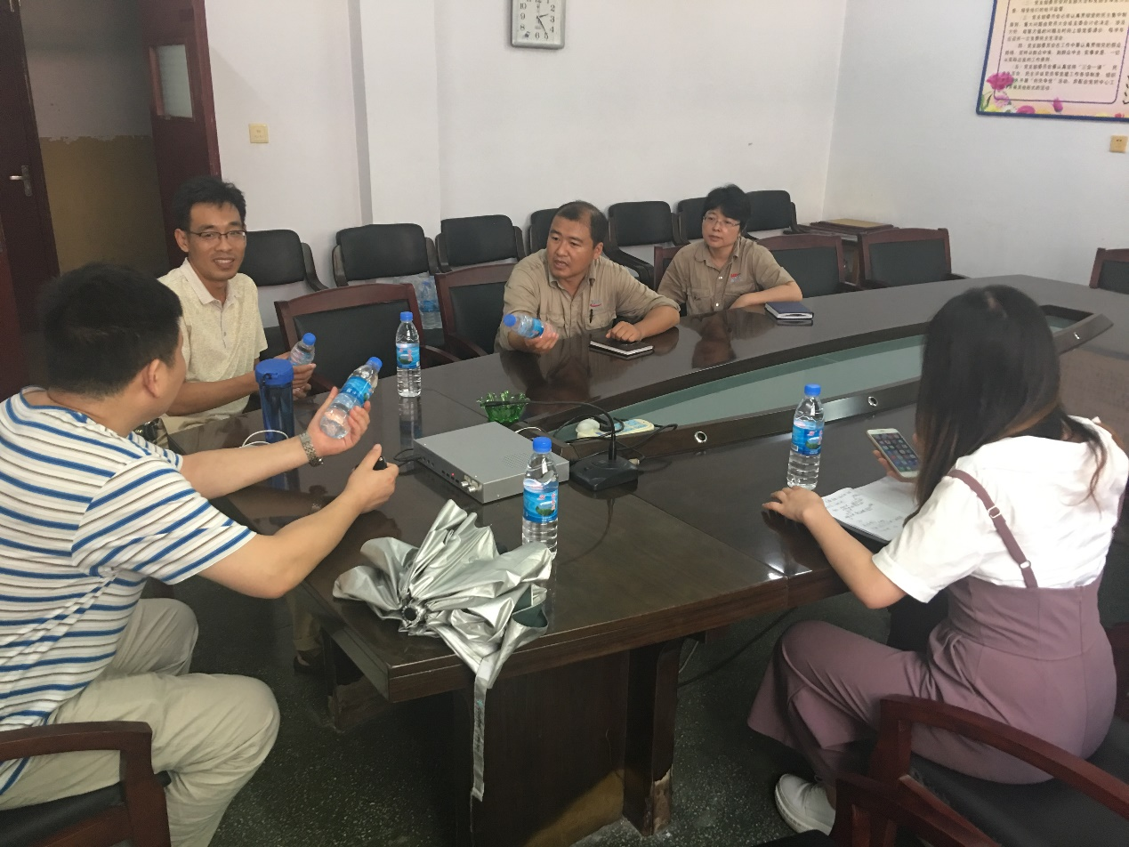

然而，自然状态下酵母对铜离子与镉离子的耐受性是无法投入生产的。提高酵母的重金属耐受性和竞争力是我们项目的必要条件。

提高酵母在高浓度金属离子中的生长状况是我们这个项目得以应用于生产中的关键。我们选择cre-loxp系统对酿酒酵母进行快速进化，提高其对铜镉离子的抗性。cre-loxp系统是利用cre酶与染色体上的loxp位点使得］基因发生复制，翻转，移位和删除，半理性的改变染色体结构。其对基因的改造形式取决于loxp位点的方向。同向时，位点间的基因删除。反向时，位点中的基因发生翻转。位于不同染色体上的基因还可能发生易位。基于实验室人工合成的5号和10号酵母染色体，我们利用染色体各个基因之间插入的loxpsym位点,通过cre酶开启重组系统。loxpsym位点与传统的loxp位点的差异在于 其特殊的回文结构会使染色体发生各种可能的结构变化，在不同的浓度梯度的金属离子环境下，筛选出耐高浓度金属离子的菌株，使生物方法处理中重金属污染更加可行。

## 与政府、环保局携手

最终，我们带着我们的成果去往河南省鞍钢对口铁矿厂和山西省中条山有色金属公司，希望找到污染的源头，希望能从源头治理。他们告诉了我们现在中国的主要排放途径是通过排放到尾矿库，

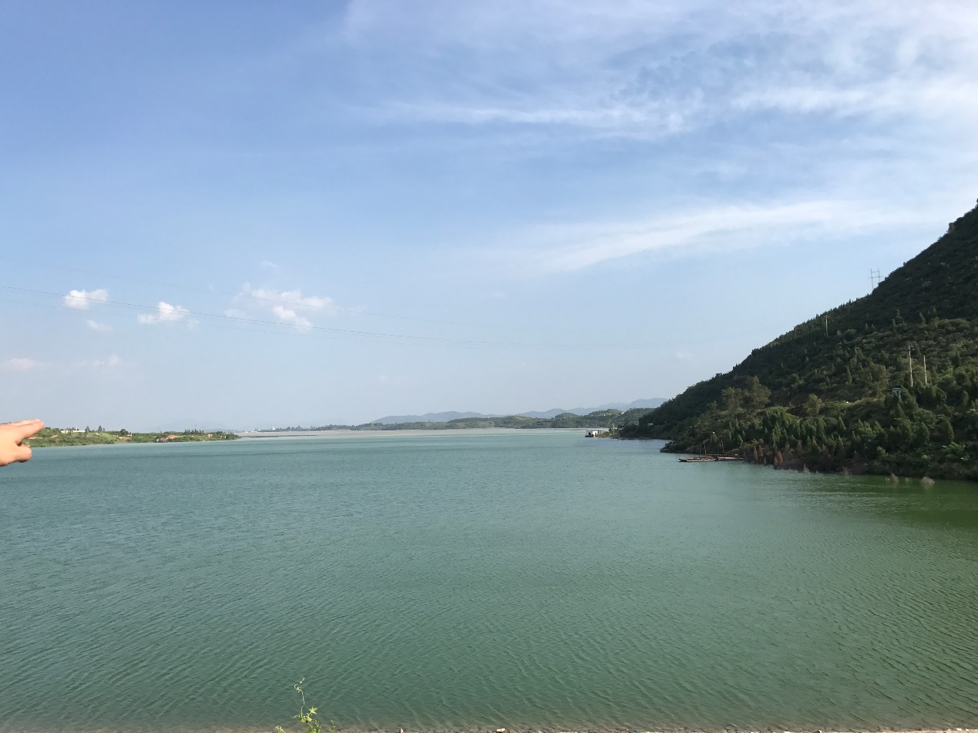

我们联系了山西省环保局，环保局的政府工作人员十分支持我们的想法，派政府专职人员带领我们去往山西的最大的一家铜矿厂，在那里，我们了解到尾矿库的存在，尾矿库是是一个专门收集污水的地方，因为处理成本高，时间长，所以环保局一般不处理，但是对于环境有一定危害，所以我们希望将来能在此处利用我们的酵母。

尾矿库是通过物理过滤方法处理重金属的，处理力度不够大，危害较大，一般交给环保局，环保局外包给重金属处理公司来处理。同时，从他们口中得知，尾矿库若处理得当，其中的价值巨大，可以重新提炼出排放到这里的重金属，创造巨大的财富。我们给他们提了建议，希望他们能考虑调取尾矿库中的水，利用我们的酿酒酵母，处理尾矿库中残余的重金属。同时我们咨询了北京、山西、河南的环保局和他们对口的外包公司：中科鼎实，有色金属公司对我们的结果进行了很好的反响，并且答应如果我们的实验到达成熟的地步，愿意做我们的第一个试验点。

## 多方交流与自我检查

我们还参加了第四界CCiC交流会，会上，我们与多支队伍交流了我们的实验，也受到了别人提出的问题：1.合成型酵母投放至自然界中会不会与自然界中的天然酵母交配，从而整合基因？2.如果可以做到把铜的检测开关原件高浓度开，低浓度关就更好。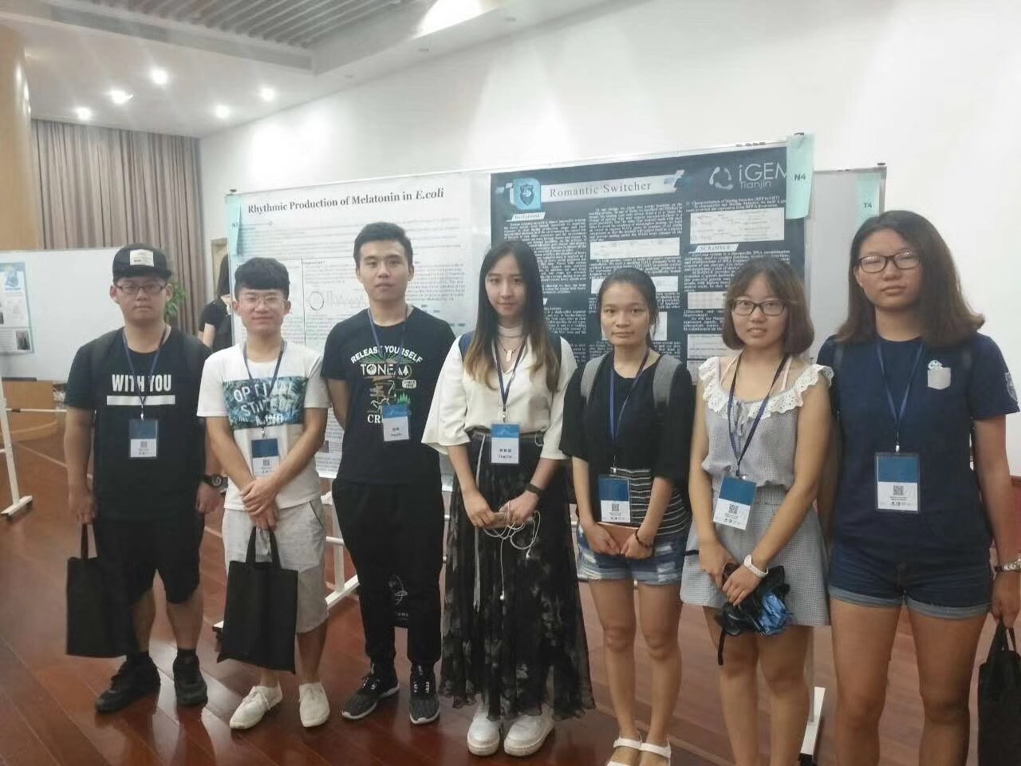

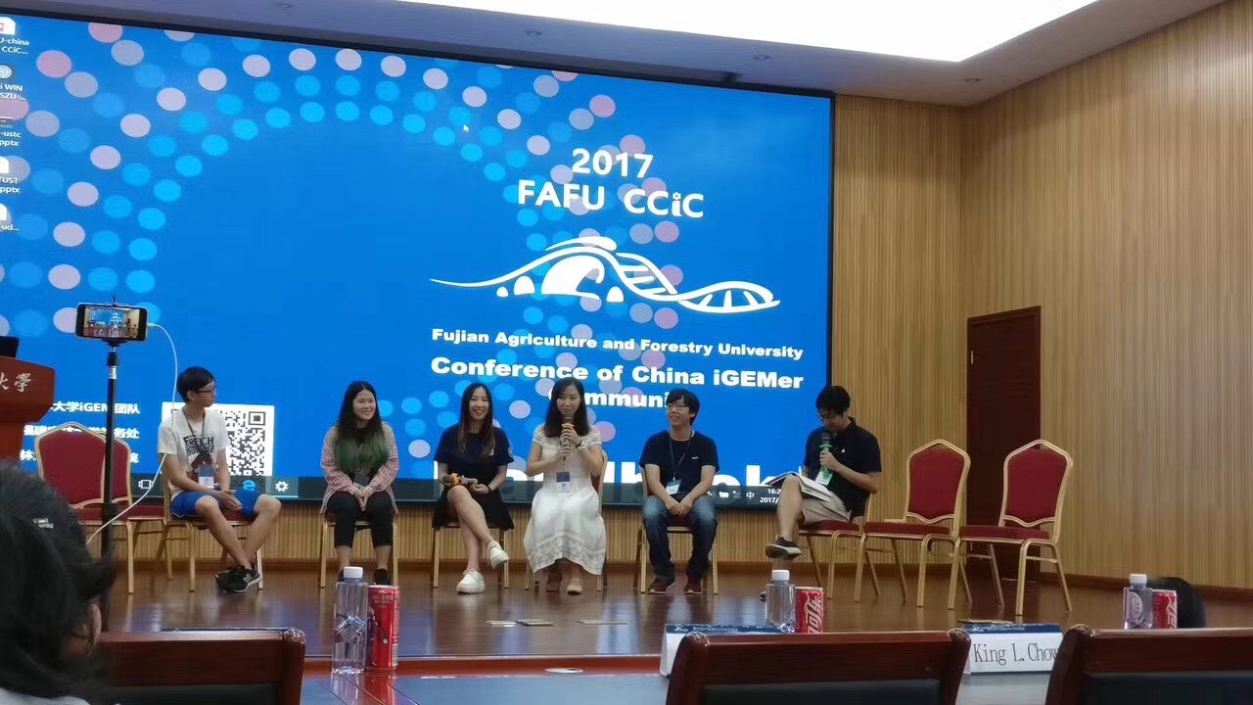

同时，我们将我们的想法与做出来的菌种和许多生物公司交谈，并且说明我们在参加这个比赛，希望他们对我们的项目进行评估和分析，如果他们认为我们的项目足够好，可以给我们一些资金或试剂上的资助。很高兴我们最终找到了

等5家公司，为我们总共提供了7万6000元人民币的赞助和许多试剂支持。